

Final Report on Telecom Churn Analysis

EDA Report

Observation Summary

This report presents the analysis of a telecom company's customer data to identify patterns of customer churn. Churn refers to customers discontinuing their services, which has a significant impact on the company's revenue. After conducting detailed exploratory data analysis (EDA), several key insights emerged:

1. High Churn Rate among Senior Citizens and Short-Tenure Customers: Senior citizens and customers with less than a year of tenure tend to churn more frequently. These groups may benefit from targeted retention strategies, such as personalized offers or improved customer service.
2. Impact of Service Features on Churn: Lack of value-added services like tech support, online security, and device protection strongly correlates with churn. Customers who lack these services show a higher tendency to leave, suggesting a need for bundling or promoting these services more effectively.
3. Price Sensitivity: Customers with higher monthly charges tend to churn at a greater rate. This suggests that the pricing structure may be perceived as too expensive or that these customers are not seeing enough value for the cost. Offering loyalty rewards, discounts, or customizable packages may help in retaining these customers.

# Full Report on Telecom Churn Analysis

### 1. Overview of the Dataset

* **The dataset consists of customer information for a telecom company, aimed at analysing churn. The key columns include:**
* Customer Demographics: customerID, gender, SeniorCitizen, Partner, Dependents
* Services: PhoneService, MultipleLines, InternetService, OnlineSecurity, etc.
* Churn Information: Churn (target variable)

### 2. General Data Cleaning and Preprocessing

* **The data cleaning involved:**
* Handling missing values.
* Converting categorical data to numerical values for analysis.

### **3. Churn Distribution Analysis**

A count plot was generated to understand the distribution of customers who churned versus those who stayed with the company. The majority of customers did not churn, but a significant portion did, which warrants further investigation.

**Observation:** The churn rate is moderately high and may indicate issues with customer satisfaction or service features.

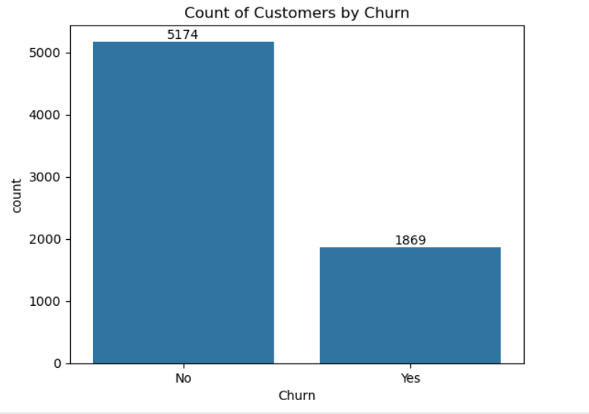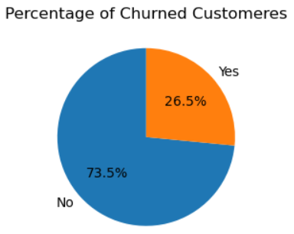

### 5. Feature-Wise Churn Impact

* **Senior Citizens**: A higher proportion of senior citizens tend to churn.

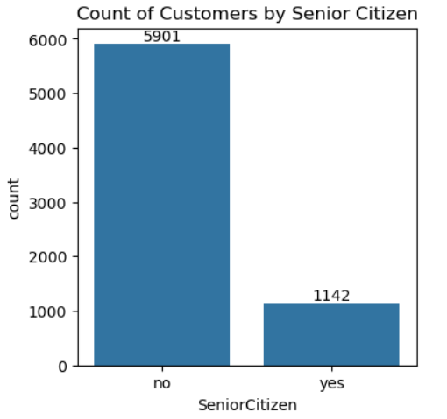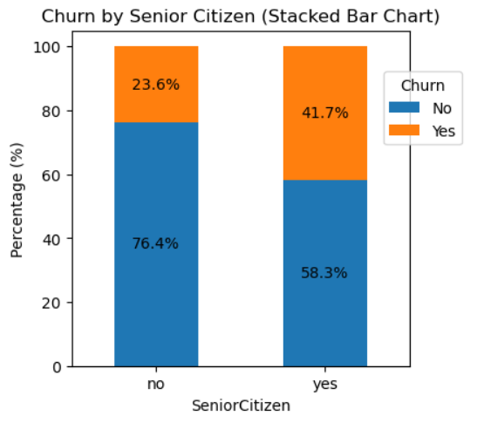

* **Dependents**: Customers with dependents churn less frequently than those without.
* 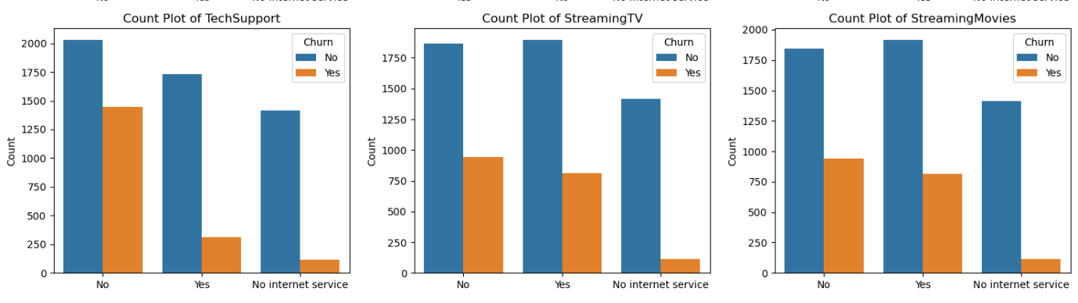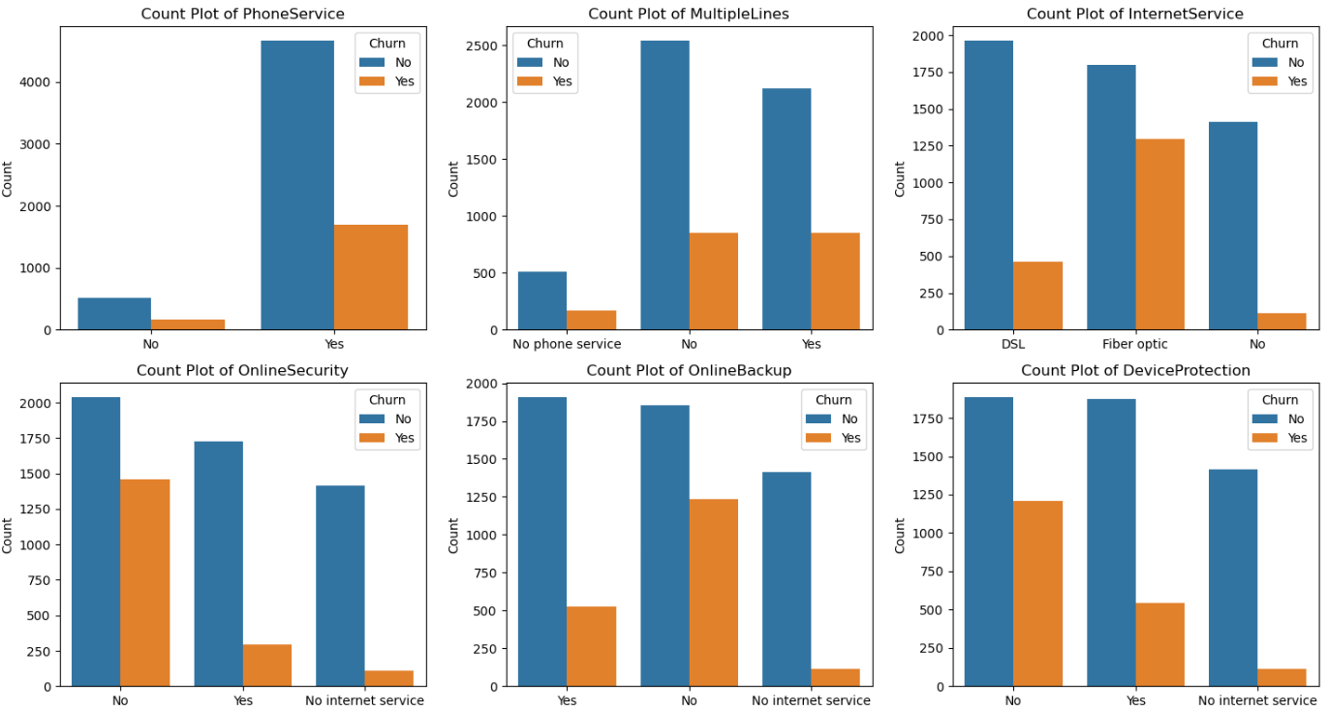**Tech Support and Online Security**: Customers without tech support and online security services tend to churn at higher rates.

### 6. Tenure and Monthly Charges

* **Tenure**: Customers with shorter tenure (less than a year) have a much higher churn rate. Longer-tenured customers tend to stay loyal.
* **Monthly Charges**: Higher monthly charges are correlated with increased churn, possibly indicating dissatisfaction with pricing.

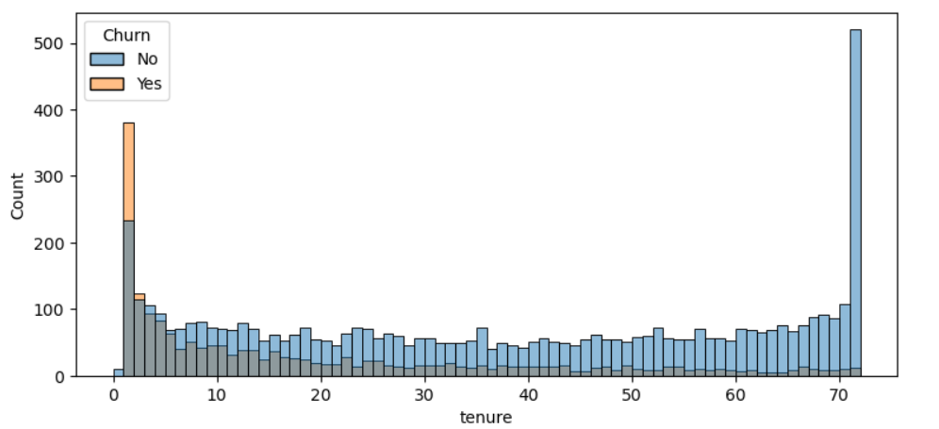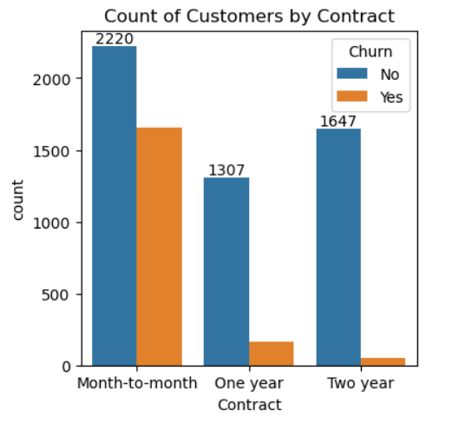

### 7. Key Takeaways and Recommendations

* **Service Quality Improvement**: Customers without tech support and online security churn more, suggesting that improving or bundling these services could reduce churn.
* **Pricing Strategy**: High churn rates for customers with higher monthly charges highlight a need to reassess pricing or offer loyalty discounts.
* **Targeted Retention for New Customers**: Since new customers tend to churn more, introducing personalized retention programs early could help mitigate churn.
* **Retention Programs** for new and senior customers,
* Offering **discounted or tiered service packages**, and
* Promoting **value-added services** like online security and tech support will significantly reduce churn.

Implementing these strategies could not only improve customer satisfaction but also drive long-term loyalty.